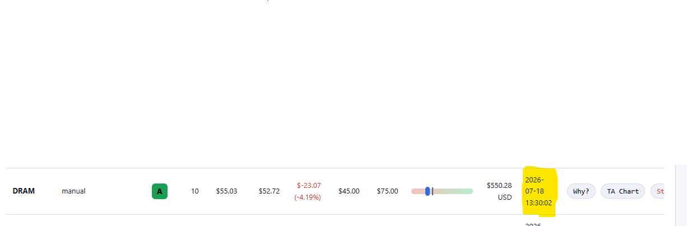
I placed a manual trade and it got executed even when market is closed

Need ability to execute trade at market price:
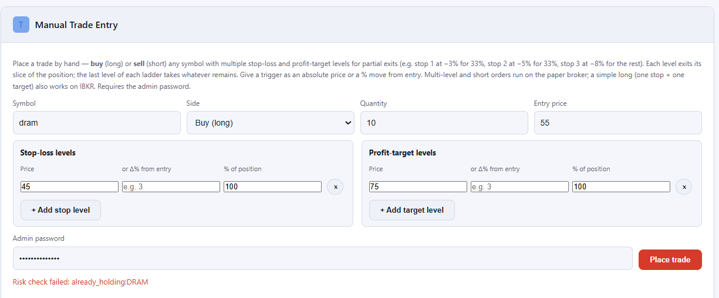
[ ] Market Price

In AI self-learning layer, how is vol x defined and calculated. If the system can provide vol x is measured and calculated. A grocery of each signal metrics and calculation.
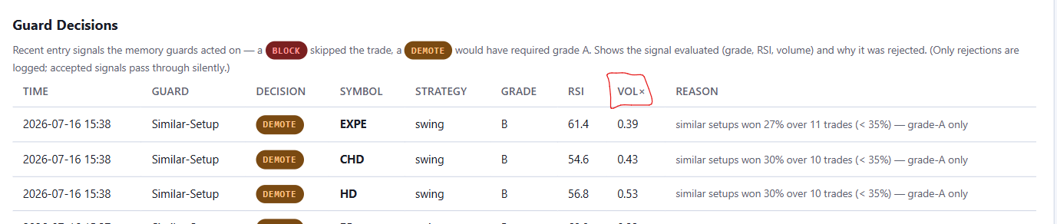

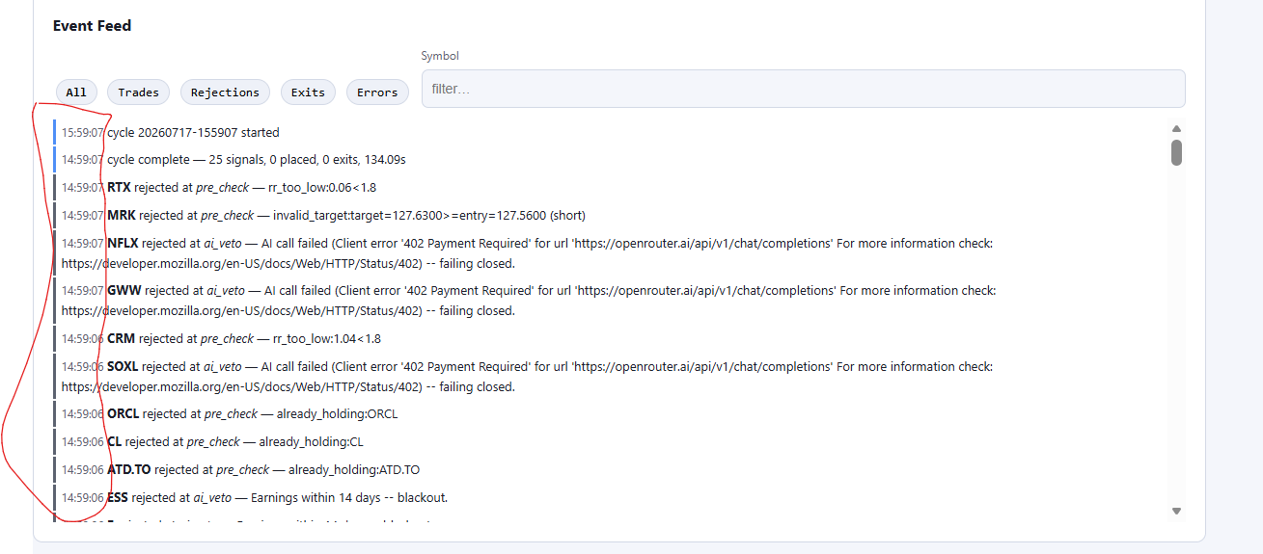
- Also in Event Feed if we can also have date against the time to better understand when these signals are generated.
- What is the criteria of AI veto.

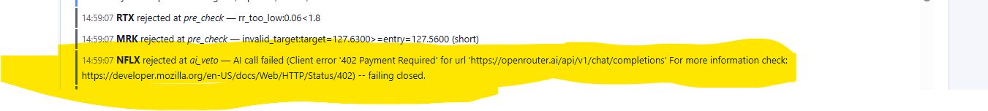
- What is AI call failed client error 402.
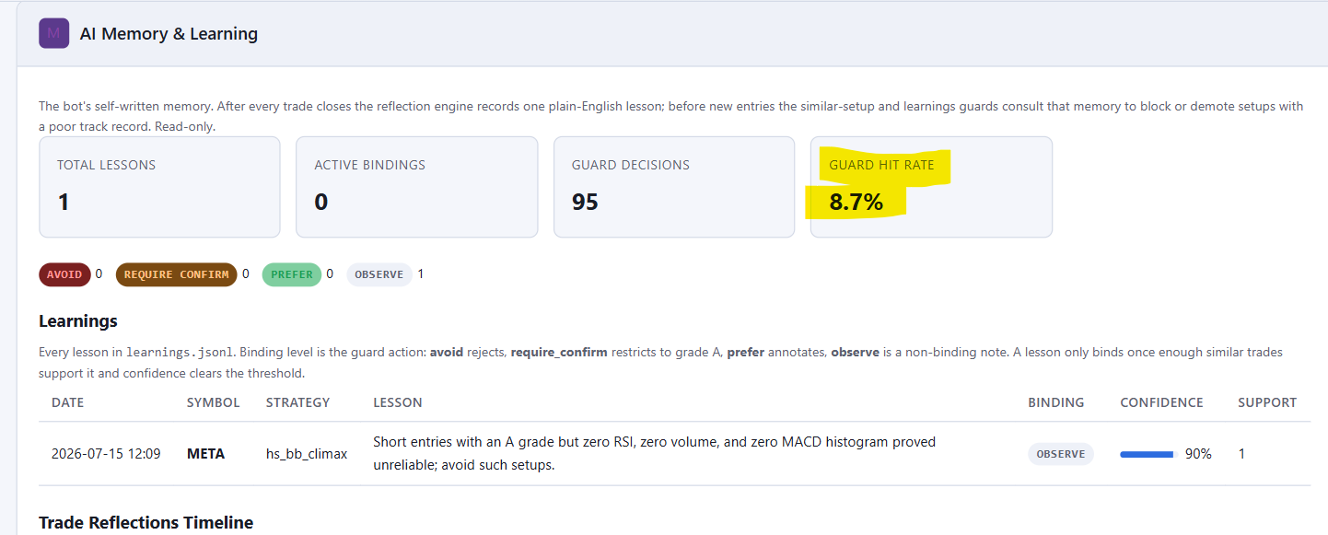
- What is Guard Hit Rate and how does that work.

